CAMP WEE LUV’EM Pre-Teens
 | June/July 2018
Sun | Mon | Tue | Wed | Thu | Fri | Sat
June 24  WELCOME TO CAMP!! | 25  Friendship Games  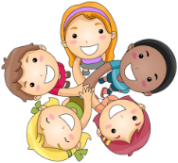 | 26  Team Building Games | 27  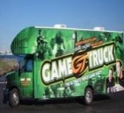  Game Truck  comes to Camp  (Teens & Pre-teens) | 28  Minute to Win it Games | 29  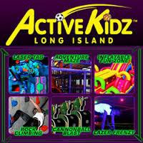  Trip to ActiveKidz | 30
1  Magic in the USA | 2  Magic Trick Monday | 3  Party in the USA  Red, white & blue day! 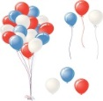 | 4  Camp Closed  Happy 4th of July!!  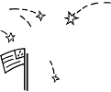 | 5  Pop, Fizz & Crackle  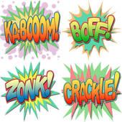 | 6  Magician Comes To  Camp! | 7  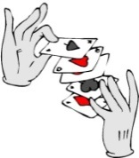
8  Camp Crazy Week | 9  Pop corn and Pajama Day  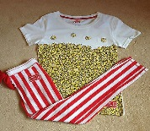 | 10  TWIN DAY!  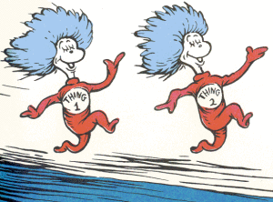  Dress like a friend! | 11  SIMPLAY | 12  Throwback Thursday dress up as a time in the past!  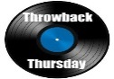 | 13  Movie Trip | 14
15  Out of This World  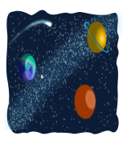 | 16  Giant Soccer Dart Board  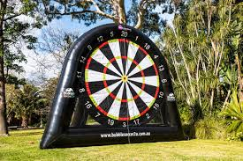 | 17  Rocket Launch  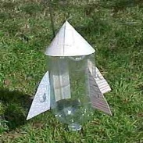 | 18  Space Race  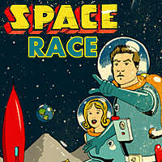  Games | 19  Alien Day!  Dress up like an alien  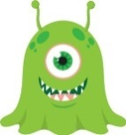 | 20  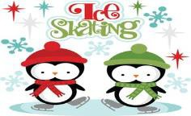  Ice Skating at  Dix Hills Rink | 21  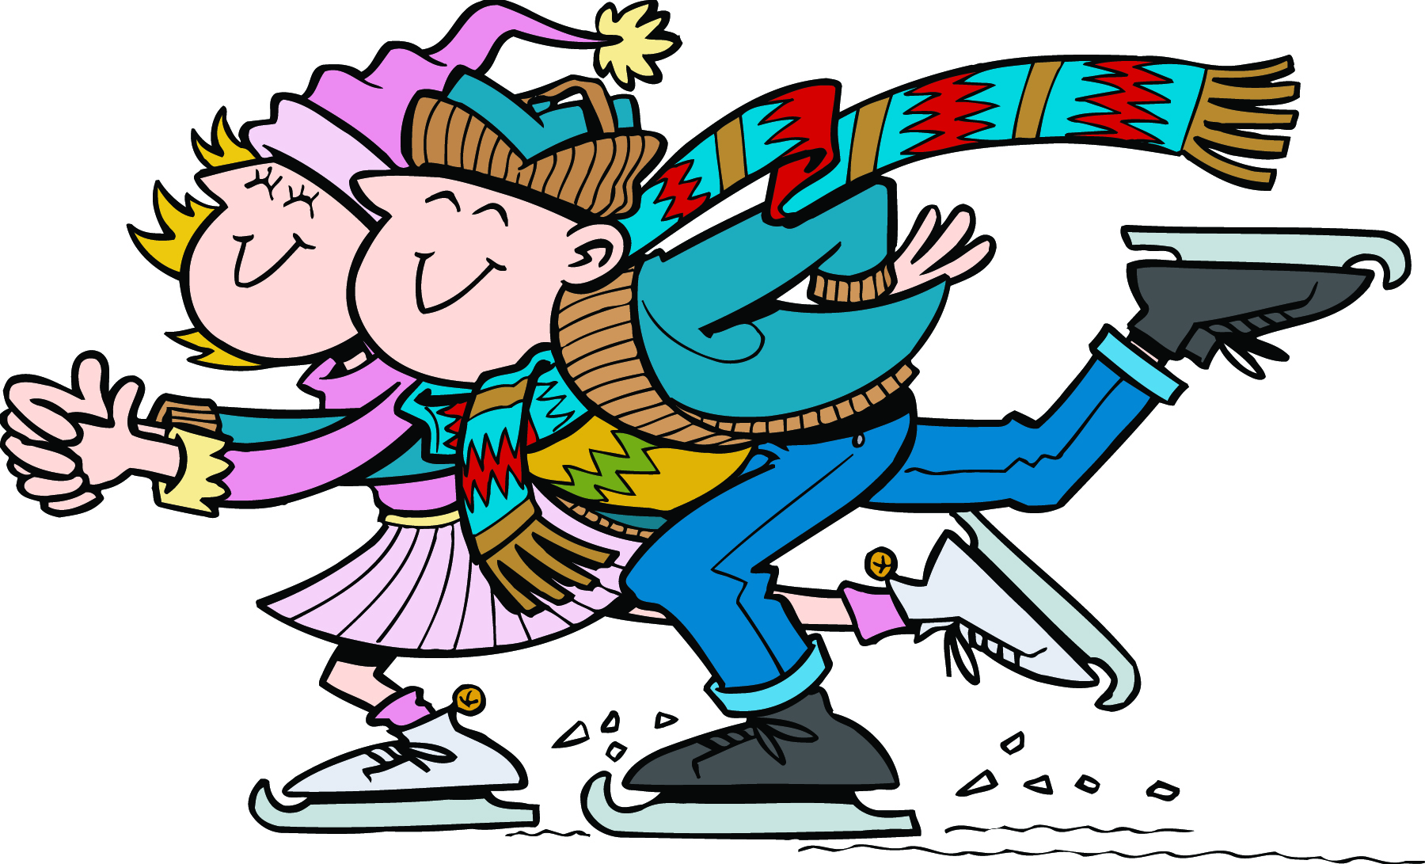
22  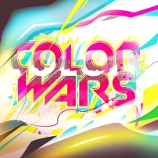 | 23  Spin Art Frisbees  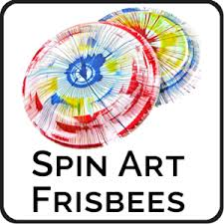 | 24  Tee Pee Building Contest | 25  Gold Rush and Relay Race  LAZERLAND pre-teen/teen | 26  Tie Dye and Race & Around Camp | 27  Game Show comes to camp  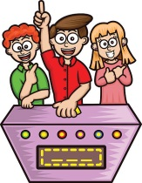 | 28  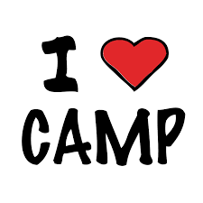

CAMP WEE LUV’EM Pre-Teens
 | July/August 2018 |  |  |  |  |  | ►
Sun | Mon | Tue | Wed | Thu | Fri |  | Sat
29  Travel the World  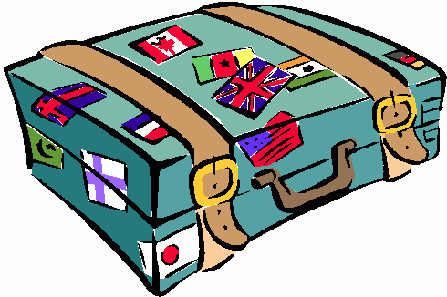 | 30  Cool Caribbean  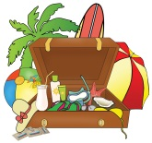 | 31  AWESOME AMERICA | 1  Magical Mexico  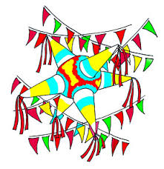 | 2  Jump For Japan | 3  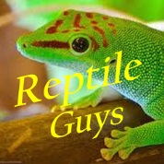  The Reptile Guys  Come to Camp  Soc Hop |  | 4  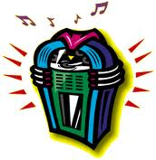
5  H2O Week  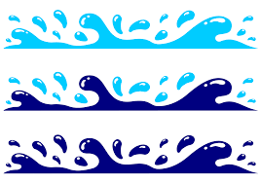 | 6  Bubblemania  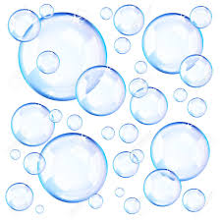 | 7  Water Wars  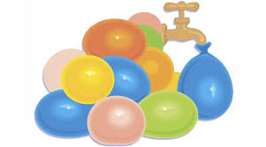 | 8  Pre teen /Teen trip to Bounce | 9  Water Balloon Games  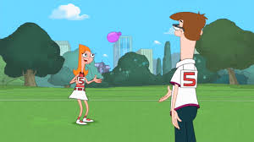 | 10  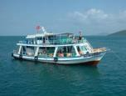  Fishing Trip (10:00-4:00) |  | 11  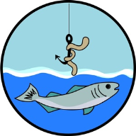
12  Olympic Week | 13  Opening Ceremony & Games  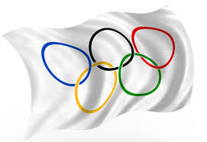 | 14 Javelin  Throw & Dodgeball  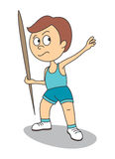 | 15  Olympic Obstacle Course  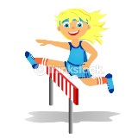 | 16 Olympic  Wacky Races  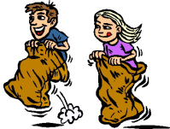 | 17  Bowling Trip with Teens |  | 18  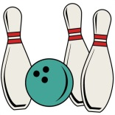
19  Wild West Week  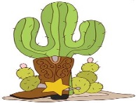 | 20  Cowboy/Cowgirl  Races | 21  Ice Cream Cone  Teepees  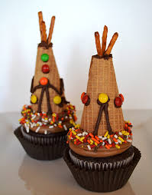 | 22  C&B Archery | 23  Wild West Games  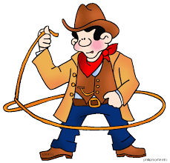 | 24  Foam Party at Camp  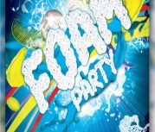 |  | 25  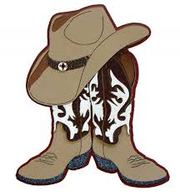
26  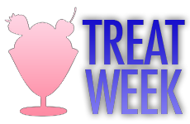 | 27  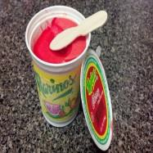  Italian Ices | 28 | 29  Waterslide at Camp!  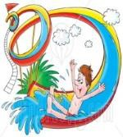 | 30  Mystery Treat! | 31  Last Day of Camp! | 1  Have a Great School Year!!

